NATIONAL BROKERS LIMITED
http://nationalbrokersbd.com/
Tea Auctioneers since 1948

TEA MARKET REPORT – Sale 29 held on Monday 25th November, 2024

CTC LEAF: 50,827 packages of tea on offer once again met with a strong demand.
BROKENS: Good liquoring Brokens were a strong market and mostly tended dearer. Below best and Mediums were a good market and were generally steady over last. Plainer types were a little easier with some withdrawals. BLF teas met with a little more interest and were slightly dearer compared to last.
FANNINGS: Good liquoring Fannings were again a strong market and were about steady. Mediums followed a similar trend and sold at around last levels. Plainer types were an easier market with some withdrawals. BLF teas met with a little more interest and were slightly dearer compared to last.

DUST: 9,039 packages of tea on offer met with a strong demand. Good liquoring Dusts were in good demand and were mostly firm. Their Mediums were also fully firm to dearer closely following quality. Plain/BLF Dusts sold around last levels with few withdrawals. Blenders lent strong support with fair interest from the Loose tea buyers.

COMMENTS: Market once again witnessed a fairly good competition with demand emanating from all sections. Blenders were more active with a little more interest from the Loose tea buyers this week.
Dusts were a dearer market.
Our Catalogue: (Sale 29) Avg : Tk 217.28, Sold 76.92 % , (Sale 28) Avg : Tk 216.67, Sold 77.97%

Quotations – This Week – (In Taka)
Exchange Rates 25th November, 2024 Sterling Pound 149.1055 Dollar: Tk. 119.0000
Brokens | This Week | Last Week | Fannings | This week | Last Week | Dust | This week | Last Week
Best | 235-245 | 235-240 | Best | 235-240 | 235-240 | PD | 205-287 | 210-283
Good | 220-230 | 225-230 | Good | 220-225 | 225-230 | RD | 160-186 | 160-295
Medium | 205-215 | 205-215 | Medium | 205-215 | 205-215 | D | 183-310 | 195-325
Plain | 180-190 | 175-185 | Plain | 180-190 | 175-185 | CD | 170-400 | 210-286
BLF | 160-165 | 160-165 nom | BLF | 160-165 | 160-165nom | BLF | 160-216 | 160-189

Top Prices – This Week
Category – CTC | Garden | Grade |  | Package | Price | Buyer(s)
Brokens | *Madhupur |  | GBOP | 20 | 275/- | GP/AKT
Fannings | *Amrail |  | PF | 30 | 280/- | Danish/AKT
Clonal Brokens | Kedarpur |  | GBOP(SPL)BT1 | 10 | 312/- | LC
Clonal Fannings | Amtali |  | GOF(S) BT2 | 10 | 323/- | BC
RD/PD (incl.Clone) | Kedarpur |  | RD(BT1) | 10 | 292/- | AKT
D (incl.Clone) | *Madhupur |  | D(BT1) | 10 | 310/- | AKT
CD (incl.Clone) | *Madhupur |  | CD(BT1) | 10 | 400/- | GP
* Above price(s) realised in our catalogue

Offerings
This Sale (Sale 29) Next Sale (Sale 30) Season 2024-25 Season 2023-24 Season 2024-25 Season 2023-24
Type | Packages | Qty/Kg | Packages | Qty/Kg | Packages | Qty/Kg | Packages | Qty/Kg
Leaf | 50,827 | 2,536,267.3 | 70,057 | 3,495,844 | 60,737 | 3,030,776.3 | 75,762 | 3,780,523.8
Dust | 9,039 | 451,046.1 | 13,792 | 688,220 | 9,885 | 493,261.50 | 13,584 | 677,841.6
Total | 59,866 | 2,987,313.4 | 83,849 | 4,184,065 | 70,622 | 3,524,037.8 | 89,346 | 4,458,365.4

Chittagong Auction Average - Sale 28
(Season 2024/25): Tk 209.05 & (Season 2023/24): Tk 177.38 & (Season 2022/23) :Tk 208.79

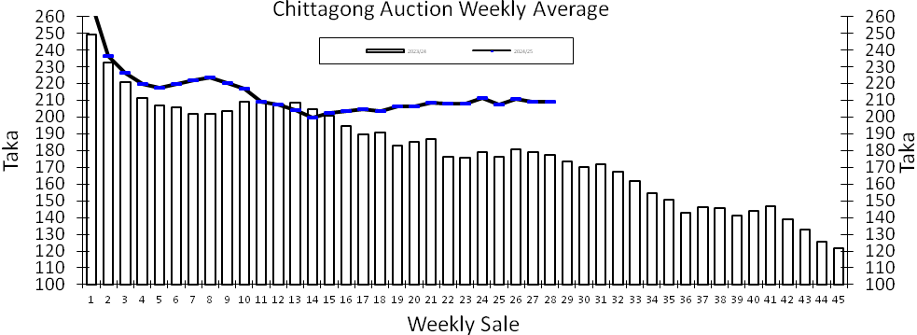
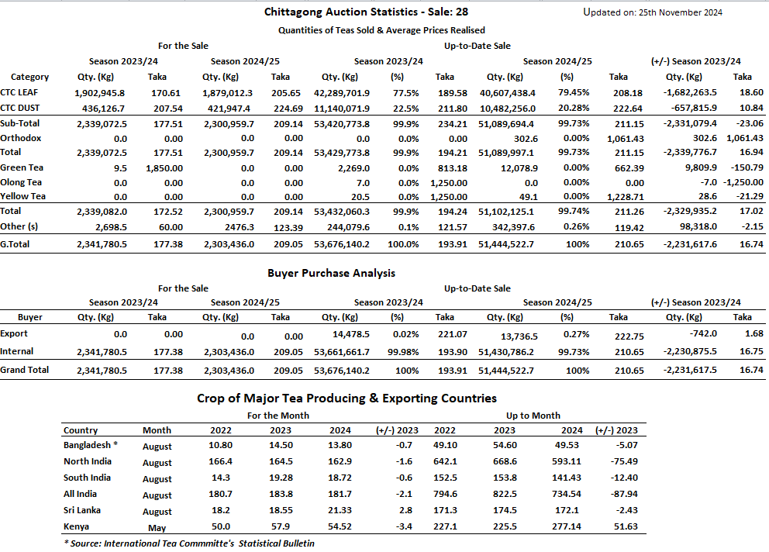

OTHER MARKETS

KOLKATA SALE 47- 19th /20th & 21st NOVEMBER, 2024
There was lower demand this week for good liquoring Assams which witnessed a further decline in levels with a large weight outlisted due to want of bids. Medium sorts too were easier. Dooars met with good demand with the bulk selling at easier rates. Dust: There was good demand. Bulk of the Assams on offer were irregularly easier. Western India segments and M/s Hindustan Unilever showed fair interest on better liquoring Assams whilst M/s Tata Consumer showed limited interest on medium sorts and plainer Dooars. Both major Blenders operated on brighter liquoring dusts along with activity from regional packeteers. Exporters showed interest on larger Brokens. Local buyers operated on clean, well-made varieties.
Tea Category | Price Range USC
BEST ASSAMS | 403-451
GOOD ASSAMS | 332-379
MED ASSAMS | 237-296
GOOD DOOARS | 285-320
MEDIUM DOOARS | 213-249
PLAINER DOOARS | 178-213
COONOOR SALE 47- 22ND NOVEMBER, 2024
DEMAND: - Good but selective demand. MARKET:- The total CTC leaf teas sold this week was 67.42% (1476388.03kgs) of the total offering of 2189734.15Kgs. Continued limited offer on best teas were seen and prices were irregular following quality. Good category teas larger Broken shed about Rs 8/10, medium Broken about Rs 3/9 whilst the smaller broken at the bottom end sold dearer by Rs 3/-whilst the top end declined by up to Rs 4/-. The Fanning grade faced withdrawals. Better medium larger broken lost Rs 8/ 10, medium Broken eased by up to Rs 4/-. Smaller Broken and Fanning sold barely steady to easier by up to Rs 2/-. Medium category larger Broken sold easier by Rs 4/8 whilst the remainders sold easier by Rs 2/ 3. Plainer teas overall lost about Rs 2/3 in comparison to last week. BUYING PATTERN:- The major blenders were fairly active absorbed only 53.74% of the total CTC leaf sold. Regional packeteers though improved their off-take but were price sensitive. Up country buyers and local traders were fairly active. Exporters improved their purchases in volume but at reduced price levels.
CTC  Leaf(USC/KG) | Best | Good | Better Medium | Medium | Plain
Larger Brokens | NQ | 147-258 | 139-146 | 119-138 | 109-117
Medium Brokens | 190-247 | 178-184 | 162-175 | 145-165 | 124-143
Smaller Brokens | 213-270 | 181-193 | 166-177 | 147-165 | 135-146
Fannings | 204-237 | NQ | 166-185 | 141-166 | 129-140
SILIGURI SALE 47- 20th NOVEMBER, 2024
Good demand. Best/good and below were generally easier. Plainer sorts were around last. Dust strong demand at last levels. All sections operated.
Quotations (USC/KG) | Brokens(USC/kg) | Fannings(USC/kg) | Dust (USC/kg)
Good / Best | 273-373 | 273-368 | 273-332
Medium/ Better Medium | 231-267 | 231-267 | 237-267
Common / BLF | 178-225 | 178-225 | 184-231
MOMBASA SALE 47- 18TH /19TH & 20TH NOVEMBER, 2024
Good general demand prevailed for the 181,370 packages (12,333,206.00 kilos) in the market with 32.25% remaining unsold.
CTC QUOTATIONS | BP1 – USC | PF1 – USC | PD – USC | D1 – USC
Best | 280 – 642 | 352 – 450 | 285 – 706 | 288 – 356
Good | 300 – 344 | 339 – 364 | 290 – 326 | 275 – 314
Good Medium | 250 – 414 | 320 – 360 | 276 – 314 | 270 – 309
Medium (KTDA) | 190 – 303 | 180 – 298 | 185 – 257 | 176 – 245
Medium (Plantations) | 154 – 202 | 154 – 246 | 206 – 267 | 180 – 226
Lower Medium | 116 – 180 | 120 – 190 | 114 – 198 | 116 – 177
Plainer | 090 – 148 | 074 – 166 | 085 – 138 | 088 – 142

